Special Council Meeting

Business Paper for Monday 29 November, 2021

Monday 29 November 2021

Civic Centre

Mayor Matt Paterson

(Chair)
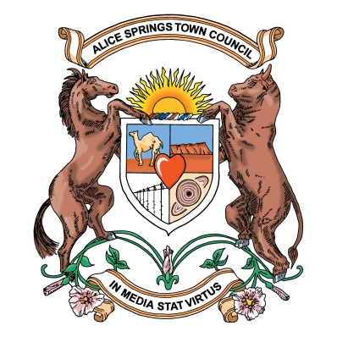

ALICE SPRINGS TOWN COUNCIL
ORDER OF PROCEEDINGS
FOR THE
SPECIAL MEETING OF THE FOURTEENTH COUNCIL
TO BE HELD ON MONDAY 29 NOVEMBER 2021
AT 5.30PM, CIVIC CENTRE ALICE SPRINGS

- OPENING OF SPECIAL MEETING AND ACKNOWLEDGEMENT OF COUNTRY
- APOLOGIES AND LEAVE OF ABSENCE
- DECLARATION OF INTEREST OF COUNCIL MEMBERS AND OFFICERS
- MASTERS GAMES 2022
- ADJOURNMENT OF SPECIAL MEETING

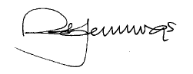
Robert Jennings
CHIEF EXECUTIVE OFFICER
26 November 2021

